Planner Master

Final Project of INFO 1213

Dr. Catherine Maydan

Nov 30, 2015

Author: JUN WANG

Student Id: 100319803

Author: CHUN –WEI, JIH

Student Id: 100290773

Introduction 3

Design 4

Coding 5

Validation 5

Test Runs 6

Output Screen 10

Issues 14

Conclusion 14

References 14

# Introduction

This project is an attempt to using web development theories of INFO1113 course to design a versatile Planner Master website for students. During this period, we went through a complete process of web development and design, from topic choice, site map and wireframe design, website stylization, coding, to programs validation.

In this project, HTML 5 was used to display and manage the website contents. Text, forms and tables were effectively organized in the webpages to provide weekly planner, monthly planner and project planner. By the use of CSS style files, structural elements such as body, header, navigation, footer were placed and displayed in a good manner for visitors to access. JavaScript and jQuery were embedded in the html files to bring a lot of alive effects to this pragmatic website. In addition, a separate style sheet was created to provide excellent printing formats for all the planners. In general, users can access, edit, save and print their favorite planners in this website.

At the final stage of this project, all html files and CSS files were validated with reporting “no errors and warnings”. The validation results were exported as PDF files and archived. Meanwhile, this website was tested and could run in good condition in Safari, Internet Explorer 9 and Chrome browsers.

This report focus on the critical parts in the development of this website, (1) web design, (2) coding, (3) test runs, (4) output, and (5) issues. It is not only a good memoir to record this project, but also helpful for new learners to sharing experience in web development.

# Design

# Coding

In this project, we used HTML, CSS, and JavaScript for coding. There are 7 html files, 2 CSS files. The file list is as below:

* index. html
* weekly.html
* monthly.html (January.html, February.html)
* project.html
* contact.html
* planner.css
* plannerprint.css

**All images of this website are archived in the “image” folder for easy management.**

**All coding files were archived in the folder named “Group Project”.**

# Validation

All html files and CSS files were validated with reporting “no error and warning”. **The validation results were saved as PDF files and archived in the folder named “Validation Result”.**

# Test Runs

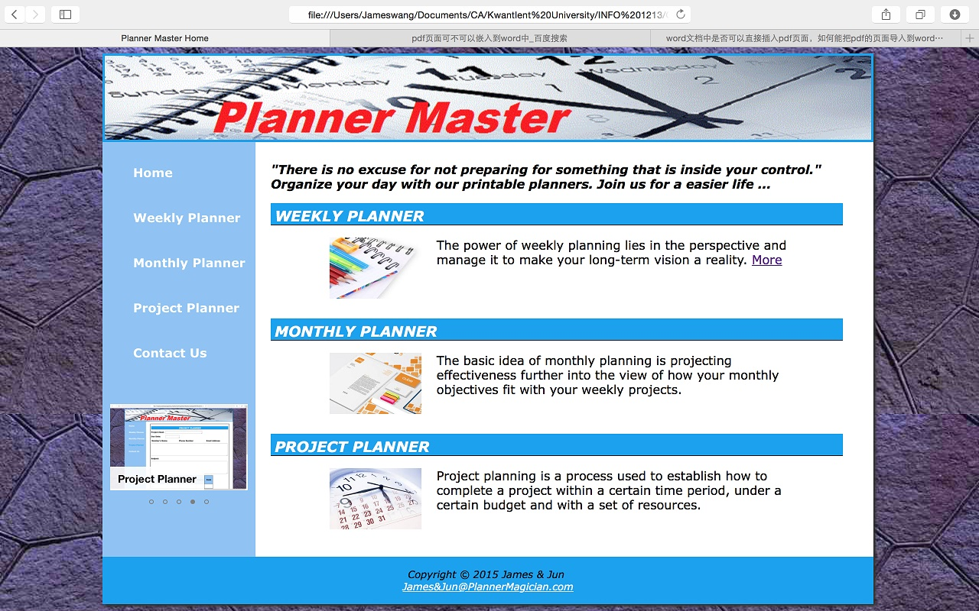Figure 1. Homepage

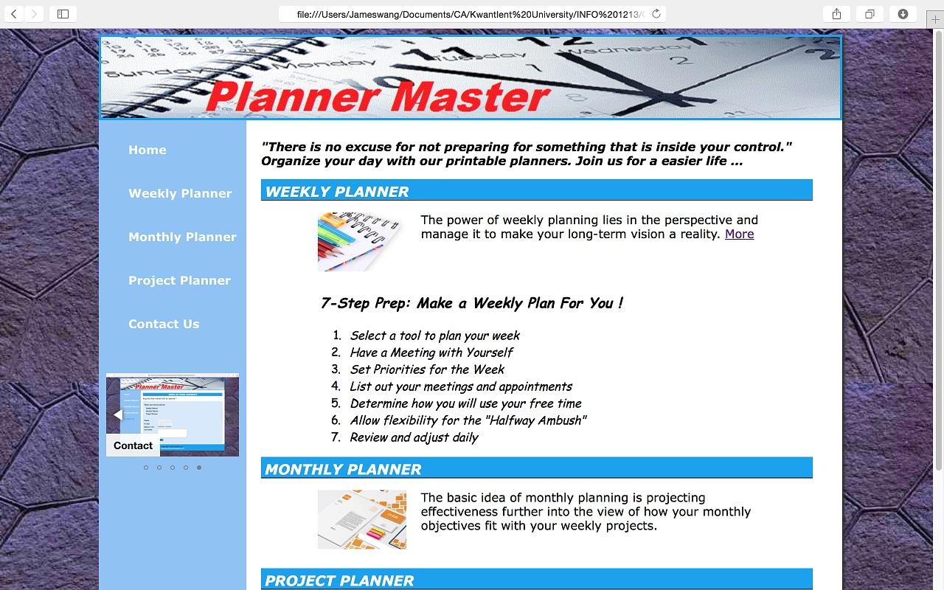

Figure 2. Homepage Extension

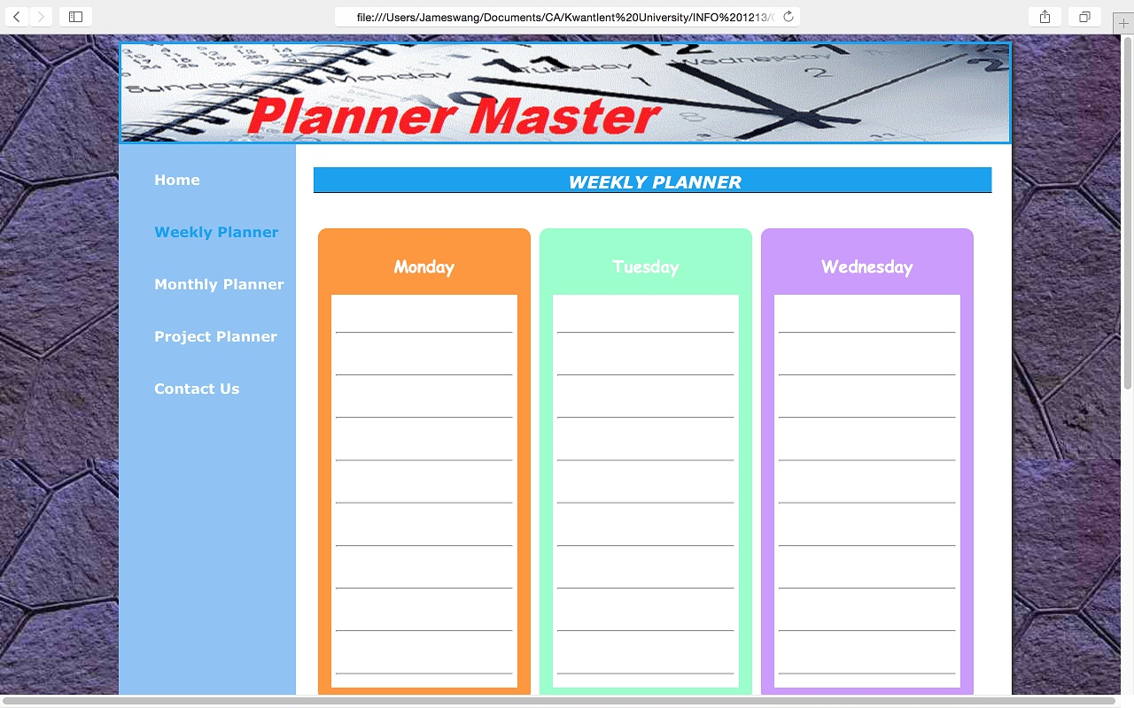

Figure 3. Weekly Planner

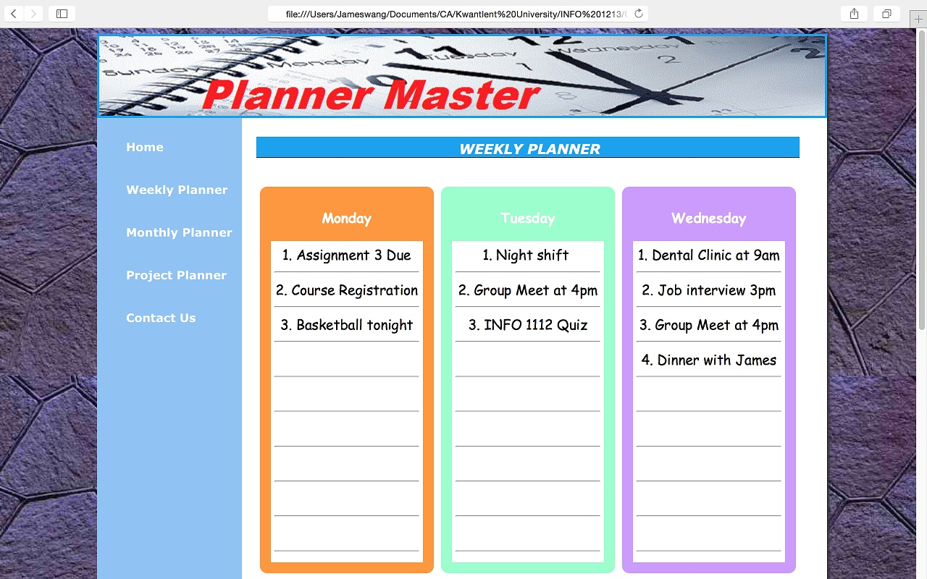

Figure 4. Weekly Planner Input

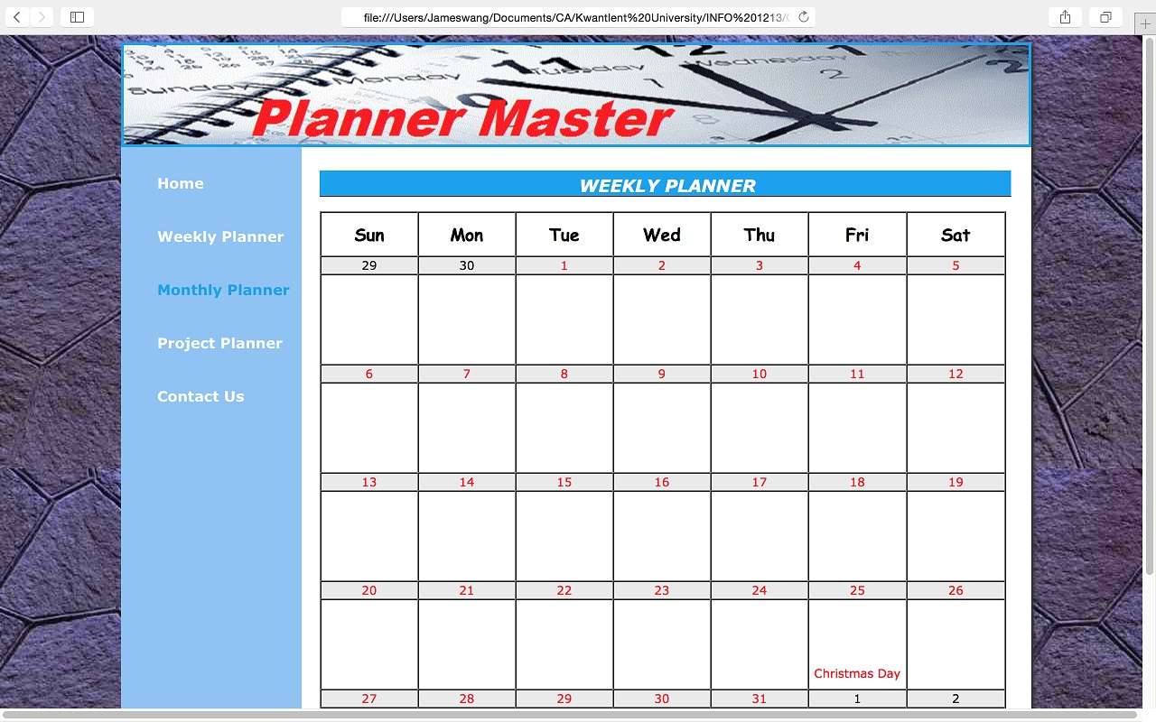

Figure 5. Monthly Planner

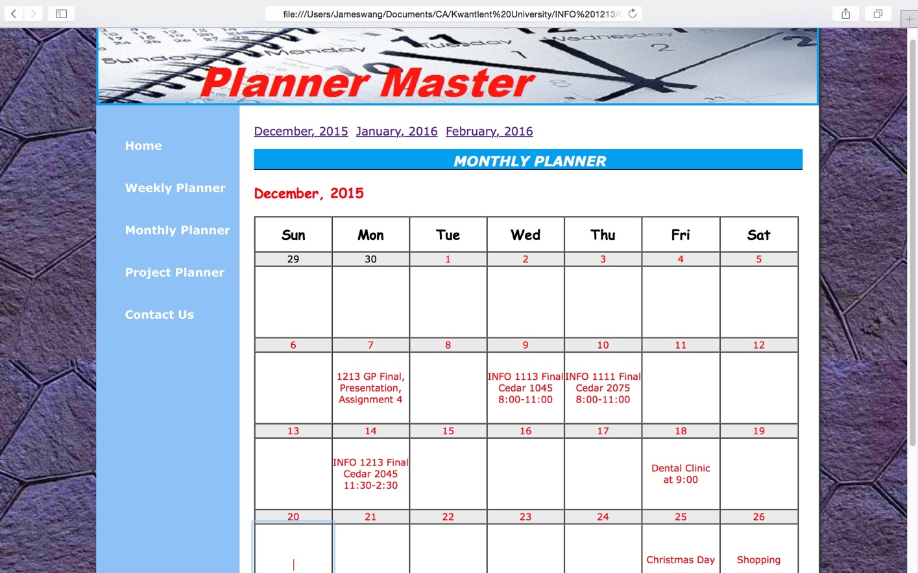

Figure 6. Monthly Planner Input

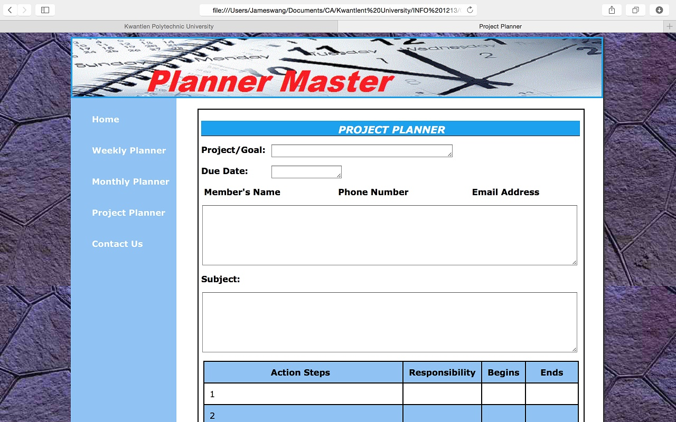

Figure 7. Project Planner

# Output Screen

Even though users prefer to edit planners on this website and save them as PDF files, they also like to have hardcopies for their planners. Therefore, we created one external style sheet named “plannerprint.css” with the special printing configurations.

In this print style sheet, we hided all non-essential contents such as Header, Navigation, Footer and other extraneous areas from appearing on the printout. Meanwhile, we adjusted the size of main region, configured font size and color for printing, and prevented background colors and background images from printing.

In the coding part, we configure the link element with media=”plannerprint.css”,

<link rel=”stylesheet” href=”plannerprint.css” media=”print”>

CSS part:

header, nav, footer {display: none;}

main {padding: 10px 20px 10px 20px;

margin:0 10% 0 0;

background-color: #ffffff;

color: #000000;

overflow: auto;

}

By the use of plannerprint.css, this website can output weekly planner, monthly planner and project planner for users to manage their time easily. User can also edit their planners online and save them as PDF files. The screen shots of them show as figure 6, figure 7, and figure 8.



Figure 9. Weekly Planner Output

Figure 10. Monthly Planner Output



Figure 11. Project Planner Output

# Issues

This project is an attempt to using web development theories of INFO1113 course to design a versatile Planner Master website for students. During this period, we went through a complete process of web development and design, from topic choice, site map and wireframe design, website stylization, coding, to programs validation.

# Conclusion

This project is a good opportunity to practice web design. There were three important stages in this process: (1) understanding users’ requirements so as to complete the preliminary design, (2) coding with HTML 5, CSS, and JavaScript, (3). validating HTML and CSS files and testing in various browsers. Meanwhile, web development and design is an iterative work which consists of a great deal of coding and testing. It is also an endless journey of innovation and

# 

# References

References

Guide to Write a Project Report. Retrieved from <https://newton.ex.ac.uk/handbook/PHY/forms/WLB010919-4.pdf>